Project: GitHub
Version: 0.1
Status: Draft
Source: Atos

Contents
Setting Up GitHub 3
Cloning a Repository 3
Working with Branches 3
Staging and Committing Changes 3
Pushing and Pulling Changes 4
Pull Requests (PRs) 4
GitHub Protection Rules 4
Git LFS (Large File Storage) 5
Best Practices 5
Filter-Repo 5
Troubleshooting 6

Setting Up GitHub
- Install Git:
Download and install Git from https://git-scm.com.
- Create a GitHub Account:
Sign up at https://github.com.
- Configure Git:
- git config --global user.name "Your Name"
git config --global user.email "your.email@example.com"

Cloning a Repository
Cloning creates a local copy of a GitHub repository.
Steps:
- Navigate to the repository on GitHub.
- Click Code → Copy the HTTPS URL.
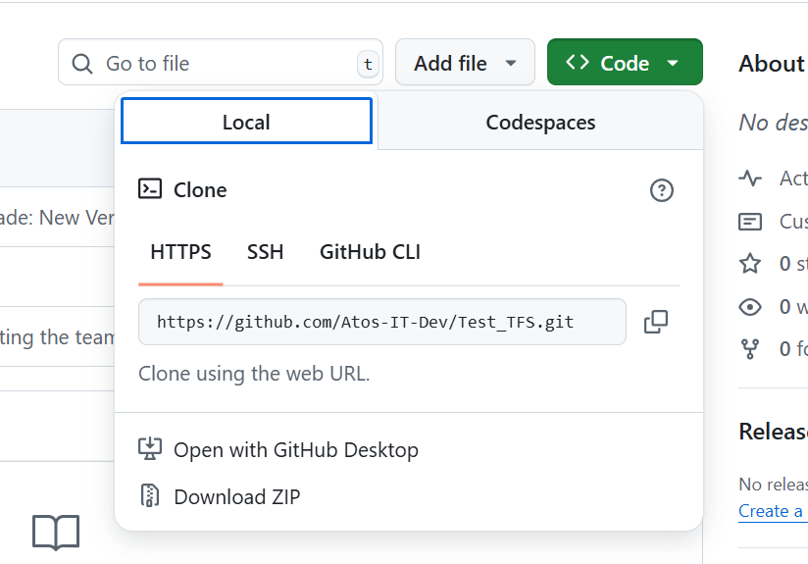
- Run: git clone <repository-URL> in the command prompt.

Working with Branches
Branches allow you to work on features or fixes without affecting the main codebase.
Common Branches:
- main or master: Production-ready code.
- develop: Active development.
- Feature branches: For new features (feature/login-page).
- Bugfix branches: For fixing issues (bugfix/header-fix).
Commands:
# Create a branch
git checkout -b feature-branch
# Switch branches
git checkout main
# List branches
git branch

Staging and Committing Changes
Git uses a staging area to prepare changes before committing.
Steps:
# Add specific file
git add filename.txt
# Add all changes
git add .
# Commit changes with a message
git commit -m "Added login functionality"

Pushing and Pulling Changes
- Push: Uploads changes to GitHub.
- Pull: Downloads updates from GitHub.
# Push branch changes
git push origin feature-branch
# Pull updates from remote
git pull origin main

Pull Requests (PRs)
A pull request allows team members to review and merge changes.
Steps:
- Push your branch to GitHub.
- Open the repository → Pull requests → New pull request.
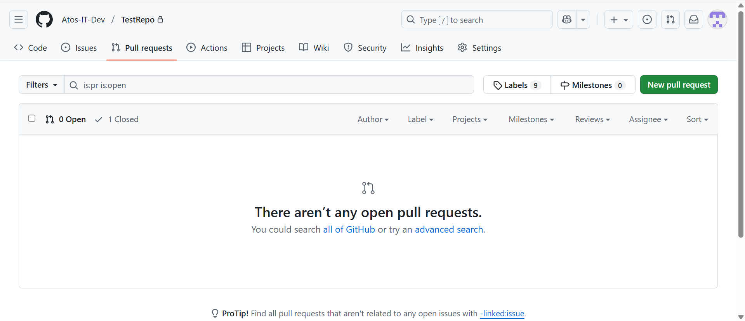
- Select base (e.g., main) and compare branch (your branch).
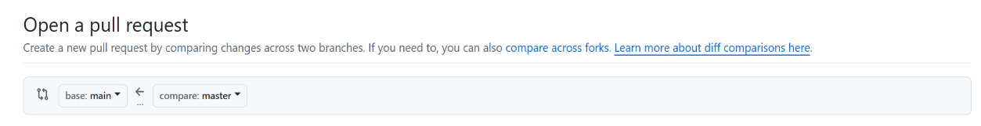
- Add description and reviewers.
- Submit PR.

GitHub Protection Rules
To ensure code quality and security, repositories can have branch protection rules.
Common Rules:
Require pull request reviews before merging.
Require status checks (CI/CD pipelines) to pass.
Restrict who can push to branches.
Require signed commits.
How to Set Up:
- Go to Settings → Branches.
- Add rules for main or any protected branch.
- Enable required checks.

Git LFS (Large File Storage)
GitHub has a file size limit (100 MB). To handle large files like datasets, images, or binaries, use Git LFS.
Installation
- Install Git LFS:
- git lfs install
- Track large files (e.g., .zip, .psd, .mp4):
- git lfs track "*.zip"
git lfs track "*.psd"
git lfs track "*.mp4"
- Add .gitattributes to the repository:
- git add .gitattributes
git commit -m "Configured Git LFS"
Usage
- When you add and commit files tracked by LFS, only references are stored in Git history. The actual file content is stored separately.
Example:
# Add a large file
git add large-dataset.zip
git commit -m "Added dataset with LFS"
git push origin main
Git LFS ensures repositories remain lightweight and prevents exceeding GitHub’s file size limits.

Best Practices
- Use meaningful commit messages.
- Keep branches small and focused.
- Regularly pull changes to avoid conflicts.
- Always work on feature/bugfix branches, not directly on main.
- Use .gitignore to exclude unnecessary files.
- Protect sensitive data (don’t commit passwords or API keys).
- Use Git LFS for large files.

Filter-Repo
git filter-repo is a powerful tool used to rewrite Git history. It is the recommended replacement for the older git filter-branch command. This tool allows you to remove large files, sensitive data (like passwords or API keys), or entire folders from a repository’s history.
When to Use Filter-Repo
- Removing accidentally committed secrets: If credentials or sensitive information were pushed, filter-repo can erase them from all commits.
- Reducing repository size: Helps clean out large files or binaries that were mistakenly committed without LFS.
- Migrating projects: Extract a subdirectory into a standalone repository.
- Restructuring history: Clean or reorganize commits before open-sourcing a project.
Example Commands
# Install git-filter-repo (if not included with Git)
pip install git-filter-repo
Note: To install git-filter-repo you need latest version of python.
# Remove all .zip files from history
git filter-repo --path "*.zip" --invert-paths
# Remove a folder from history
git filter-repo --path docs/ --invert-paths
# Replace sensitive text across history
git filter-repo --replace-text replacements.txt
Note: History rewriting changes commit hashes. After running filter-repo, you will need to force push (git push --force) and collaborators must re-clone the repository.

Troubleshooting
- Merge Conflicts: Occur when multiple changes affect the same code.
- git pull origin main
# Fix conflicts in files, then:
git add .
git commit
- Authentication Issues: Use SSH keys or GitHub CLI.
- Large Files: Ensure Git LFS is installed and configured.

